DPS P6 EXTRACTOR
Optimize your project controls!

ACESS GRAPHICS AND REPORTS INSTANTLY
THE COMMUNICATION OF YOUR PROJECT DOES NOT NEED TO BE COMPLICATED!
How much does it take for you to obtain utilized information on your project? How much time does your team take on generating that information?
Communication is vital to the success of your project!
The faster you have access to the progress and identifying eventual deviations, the bigger will be your chances to act and recover delays.
Your S Curve in just two steps.
Extract the data and visualize it!

You may have immediate access to graphics and reports of your projects managed with Primavera P6 in only two steps:

• Use the DPS P6 Extractor to extract updated information of your projects directly to a P6 database;

• With a concluded extraction access immediately your graphic and reports will be displayed in Power Bi or in your preferred reports generator.

How does the DPS P6 Extractor works?

DPS combines the most efficient technologies to generate the information you need!

Q: How can I be sure if the extracted information are the real information of my P6 project?
A: P6 Extractor utilizes a Primavera API developed by the very same manufacturer of Primavera P6®. You will be sure that you will be visualizing data from a trustable source, that is not subjected to human errors of treatment that occurs with manual extraction processes.

Q: My team already utilizes another tool. What are the options available?
A: Together with the P6 Extractor, you will receive an S Curve ready to use in your Oracle Application Express (APEX) or Power BI Desktop®. The panel is configurated according to market practices, that it, time x progress (forecasted, actual and earned value). You just need to access the panel and see the S Curve reflect the data updated by the team on Primavera P6®. If you prefer, you can even export your data to Excel® or your favorite tool. Drill down from top WBS through the activities in each level.
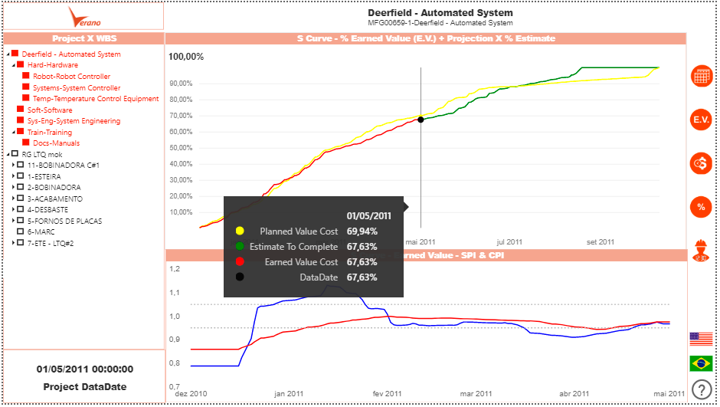

S CURVE
Browse into your extracted projects and analyze the performance of each WBS to identify the origin of eventual detours:

- Choose a project
- Select any WBS or whole project
- Visualize an S Curve!

- Visualize a Curva S!

CONTACT US: VERANO ENG SISTEMAS LTDA.
Phone +1 786 3810356 / E-mail info@verano.com.br /Website info: www.veranocorp.com / Address: 1100 South Federal Hwy Ste 200 Deerfield Beach, FL 33441 Suite #1

